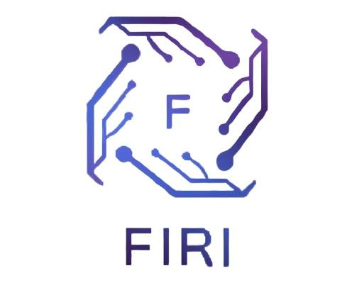Applying to FIRI

We are glad that you are interested in the Future Innovators Research Institute. In order to apply, you must first meet the following requirements:

1. Living in the United States
2. In High School (grades 9-12)

Fill out the PDF and email it to [*adrian.s.pham@gmail.com*](mailto:adrian.s.pham@gmail.com). The FIRI team will review your application and respond within 1-2 weeks.

FIRI is a program dedicated to high school students who are interested in pursuing their science related interests and bring their skills to the next level. We give access to state-of-the-art tools for developing science fair projects, from reviewing science fair abstracts to developing a project timeline. We also have a program, Operation Pipette, which allows students within the Greater Los Angeles area to gain skills in wet lab and research environments to bring them to prestigious universities and further their careers in science.

**Part 1: Basic Information**

Full Name: Click or tap here to enter text.

Email Address: Click or tap here to enter text.

Phone Number: Click or tap here to enter text.

Current High School: Click or tap here to enter text.

Expected Graduation Year: Click or tap here to enter text.

City & State: Click or tap here to enter text.

Which STEM fields are you most interested in? (Select up to three)

[  ] Biology / Life Sciences

[  ] Chemistry / Materials Science

[  ] Physics / Astronomy

[  ] Computer Science / AI / Machine Learning

[  ] Engineering / Robotics

[  ] Environmental Science

[  ] Mathematics / Statistics

[  ] Other: _________________

What has been your favorite science or technology class so far, and what did you enjoy most about it? (Short answer, 2-3 sentences)

Click or tap here to enter text.  
  
Outside of school, how do you engage with your scientific interests? (e.g., online courses, reading, personal projects, clubs, etc.)  
Click or tap here to enter text.  
  
Why are you interested in joining the Future Innovators Research Institute? What do you hope to learn or achieve? (Short answer, 3-5 sentences)

Click or tap here to enter text.  
  
  
  
  
  
Our flagship program, "Operation Pipette," is designed to provide hands-on lab experience. What excites you most about the possibility of working in a real research environment?

Click or tap here to enter text.  
  
  
Looking ahead, how do you envision research or innovation playing a role in your future academic or career goals?

Click or tap here to enter text.

Describe a time you encountered a challenging problem or a concept you didn't understand. What steps did you take to tackle it? (Short answer, 3-5 sentences)  
Click or tap here to enter text.

If you had the resources to start a research project today, what question would you want to investigate? (It doesn't have to be a formal proposal, just tell us what you're curious about!)  
Click or tap here to enter text.

Have you ever participated in a science fair or completed a major research project before?

- If yes, please briefly describe the project and what you learned from the experience. Prior experience is not required for admission.

Click or tap here to enter text.

How did you hear about FIRI?

[  ] School/Teacher

[  ] Science Fair

[  ] Social Media

[  ] Friend or Family Member

[  ] Online Search

[  ] Other

The initial training phase of "Operation Pipette" requires a commitment of approximately 4 hours per week for 4 weeks. Please confirm you can meet this time commitment.

[  ] Yes, I can commit to the program schedule.

Date: __________________________